A
Project Report on

“Bank Dataset”
Submitted at
Fortune Cloud Technology, Pune

Submitted by:
Gauri Arun Pise

Email:
gauripise190@gmail.com

Guided by:
Varsha Patil

Technology Used:
Microsoft Excel
Microsoft Power BI
Tableau Public Edition

Batch:
6th Jan,2025

: ˙ . Project Report: Spotify Dataset

INDEX

Section | Title
1 | Project Title
2 | Objective
3 | Tools & Technologies Used
4 | Insights (Chart by chart)
5 | Screenshots
6 | Challenges Faced
7 | Conclusion
7 | Future Scope

1)Project Title: Bank Analysis Dashboard

2)Objective:
The objective of this dashboard is to provide a comprehensive overview of customer account activities, loan distribution, and credit utilization within the bank. It enables quick monitoring of key metrics such as customer demographics, account types, transaction activity, loan status, overdraft usage, and credit card adoption. This visualization aims to assist management in tracking financial performance, identifying trends, assessing risk, and supporting data-driven decisions for customer engagement and business growth.
3)Tools and Technologies :
From above dataset I have created three dashboards in which I used three tools :
a)Microsoft Excel
b)Microsoft Power BI
c)Tableau Public Edition

4)Insights: Chart-by-chart analysis

A)Excel:

1)Chart Type: Column chart
Insight: Branch wise customer distribution
Minimum count of customer: 19794 and Branch : North
Maximum count of customer: 20186 and Branch: East

2) Chart Type : Pie chart
Insight: Sum of overdraft used
Yes: 42185553.58(51%)
No: 41308949.02(49%)

3) Chart Type: Bar chart
Insight: Avg txn value comparison
Minimum txn value: 2502.69 and Account type: Saving
Maximum txn value: 2515.35 and Account type: Credit

4) Chart Type: Pie chart
Insight: Gender wise customer distribution
Minimum customer: 33279(33%) and Gender: Male
Maximum customer: 33363(34%) and Gender: Other

5) Chart Type: Line chart
Insight: Activity over trend
Minimum count of customer: 7657 and Month :Feb
Maximum count of customer : 8543 and Month : Dec

6) Chart Type: Column chart
Insight: Transaction per branch
Minimum transaction: 49417588 and Branch: North
Maximum transaction: 50305400 and Branch: East

7) Chart Type: Area chart
Insight: Sum of loan amount by year
Minimum loan amount: 8295121.4 and Year: 2015
Maximum loan amount: 724292713.7 and Year: 2025

8) Chart Type: Column Chart
Insight: Currency wise customer distribution
Minimum customer: 24825 and Currency: EUR
Maximum customer: 25268 and Currency: USD

9) Chart Type: Pie Column
Insight: Customer distribution loan type wise
Minimum customer: 7411 (7%) and Loan type: Personal
Maximum customer: 70114(8%) and Loan type: Unknown

B)Microsoft Power Bi:
1) Chart Type: Column chart
Insight: Average transaction value by branch
Minimum avg txn amount: 2506.434 and Branch: East
Maximum avg txn amount:2514.494 and Branch: South

2) Chart Type: Donut chart
Insight: Customer count by branch
Minimum customer count: 19794(19.79%) and Branch: North
Maximum customer count: 20186(20.19%) and Branch: East

3) Chart Type: Treemap chart
Insight: Sum of balance by branch
Minimum balance: 1985950047.37 and Branch: South
Maximum balance: 2016907910.73 and Branch: West

4) Chart Type: Donut chart
Insight: Count of customer id by currency
Minimum count: 24825(24.83%) and Currency: EUR
Maximum count: 25268(25.27%) and Currency: USD

5) Chart Type: Stacked bar chart
Insight: Top 10 customer id by balance
Minimum balance: 19995.19
Maximum balance: 199977.7

6) Chart Type: Stacked column chart
Insight: Account types across genders
Checking: Minimum customer count: 11064 and Gender: Male
Maximum customer count: 11139 and Gender: Other
Credit: Minimum customer count: 11047 and Gender: Other
Maximum customer count: 11114 and Gender: Male
Savings: Minimum customer count: 11101 and Gender: Male
Maximum customer count: 11177 and Gender: Other

7) Chart Type: Area chart
Insights: Sum of loan amount by year
Minimum loan amount: 8295121.39 and Year: 2015
Maximum loan amount: 724292713.64 and Year: 2025

8) Chart Type: Area chart
Insights: Customer activity trend over time
Minimum customer count: 130 and Year: 2015
Maximum customer count: 9756 and Year: 2025

9) Chart Type: Stacked column chart
Insights: Average loan amount by loan type
Minimum loan amount: 74507.26 and Loan type: Education
Maximum loan amount: 77386.80 and Loan type: Auto

10) Chart Type: Stacked bar chart
Insights: Loan products popularity wise
Minimum customer count: 7360(7.36%) and Loan type: Auto
Maximum customer count: 70114(70.11%) and Loan type: Unknown

11) Chart Type: Donut chart
Insights: Count of patient id by account type
Minimum patient id count: 33265(33.27%) and Account type: Credit
Maximum patient id count:33429(33.43%) and Account type: Savings

12) Chart Type: Funnel chart
Insights: Sum of avg txn amount by account type
Minimum txn amount: 83522530.67 and Account type: Checking
Maximum txn amount: 83762862.29 and Account type: Savings

13) Chart Type: Donut chart
Insights: Credit card distribution
Yes: Count of credit card flag: 49685(49.69%)
No: Count of credit card flag: 50315(50.32%)

14) Chart Type: Clustered column chart
Insights: Count of customer id by gender
Minimum customer count: 33279(33.28%) and Gender: Male
Maximum customer count: 33363(33.36%) and Gender: Other

15) Chart Type: 100% stacked column chart
Insights: Count of customer id by loan type and gender
Minimum customer count: 7360 and Loan type: Auto
(Male: 2479, Female:2392, Other: 2489)
Maximum customer count: 70114 and Loan type: Unknown
(Male: 23339,Female: 23450, Other: 23325)

C) Tableau Public Edition

1) Chart Type: Bar chart
Insight: Branch wise loan amount
Minimum loan amount: 1472528234 and Loan amount: North
Maximum loan amount: 1516559794 and Loan amount: West

2) Chart Type: Line chart
Insight: Activity over time
Minimum customer count: 130 and Year: 2015
Maximum customer count: 9756 and Year: 2025

3) Chart Type: Pie chart
Insight: Loan type wise loan amount
Minimum loan amount: 559575297 and Loan type: Personal
Maximum loan amount: 5235505415 and Loan type: Unknown

4) Chart Type: Treemap
Insight: Transaction per branch
Minimum transaction: 49417588 and Branch: North
Maximum transaction: 50305400 and Branch: East

5) Chart Type: Bubble chart
Insight: Currency wise balance
Minimum balance: 2489802384 and Currency: EUR
Maximum balance: 2529195182 and Currency: USD

6) Chart Type: Horizontal bar chart
Insight: Branch wise customer distribution
Minimum customer count: 19794 and Branch: North
Maximum customer count: 20186 and Branch: East

7) Chart Type: Sided-by-side bars
Insight: Loan type wise gender distribution
Minimum customer count: 7360 and Loan type: Auto
(Male: 2479, Female:2392, Other: 2489)
Maximum customer count: 70114 and Loan type: Unknown
(Male: 23339,Female: 23450, Other: 23325)

8) Chart Type: Pie chart
Insight: Account type wise customer count
Minimum patient id count: 33265(33.27%) and Account type: Credit
Maximum patient id count:33429(33.43%) and Account type: Savings

9) Chart Type: Table bars
Insight: Branch Overview
Minimum customer count: 19803, and Branch: South
(Avg txn amount: 49794530 , Balance: 1985950047)
Maximum customer count: 20096, and Branch: West
(Avg txn amount: 50436585 , Balance: 2016907911 )

5)Screenshots:
A)Excel Dashboard

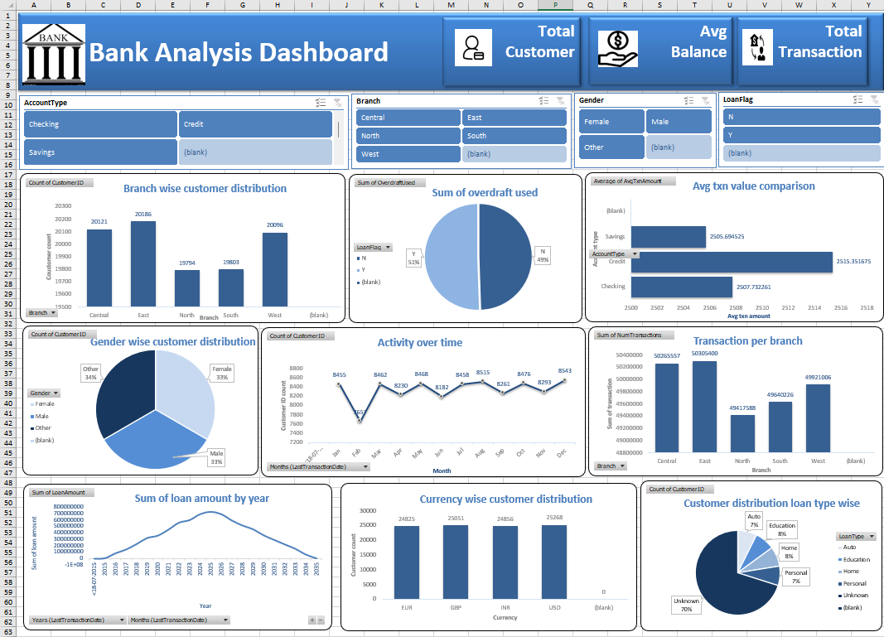

B)Microsoft Power BI Dashboard:
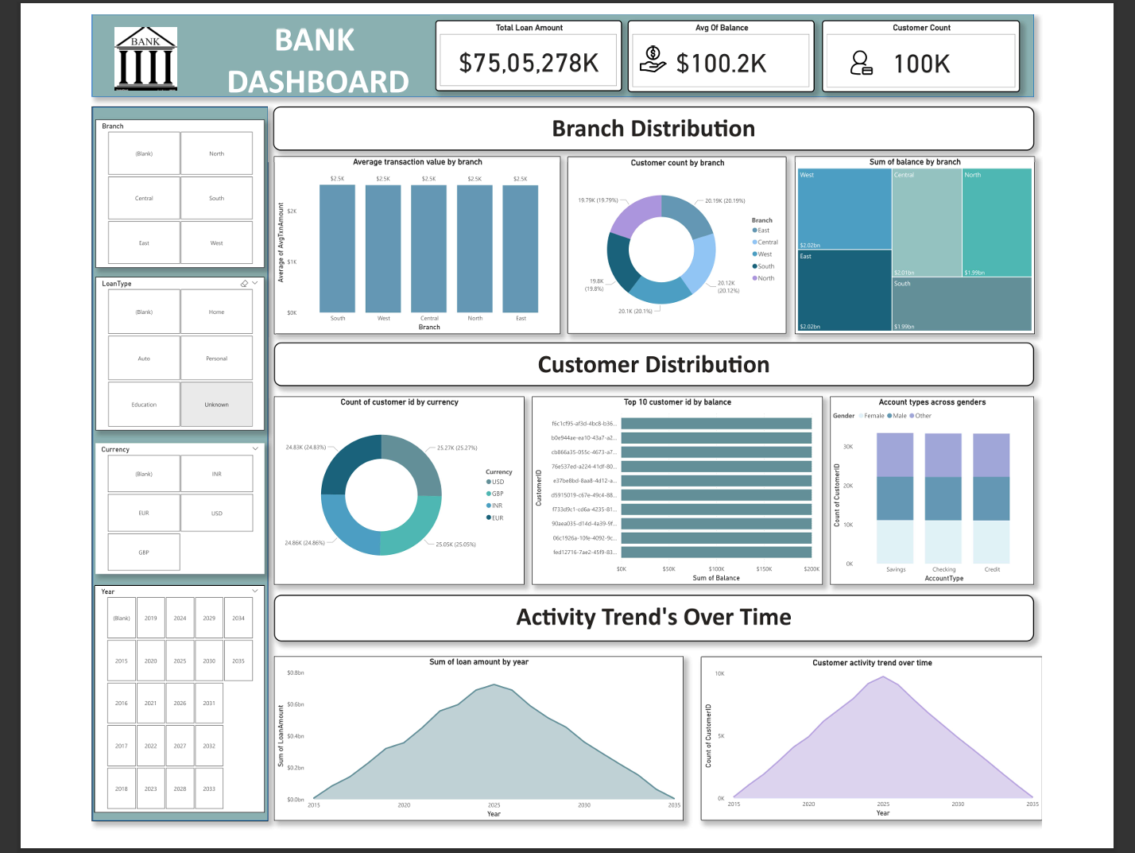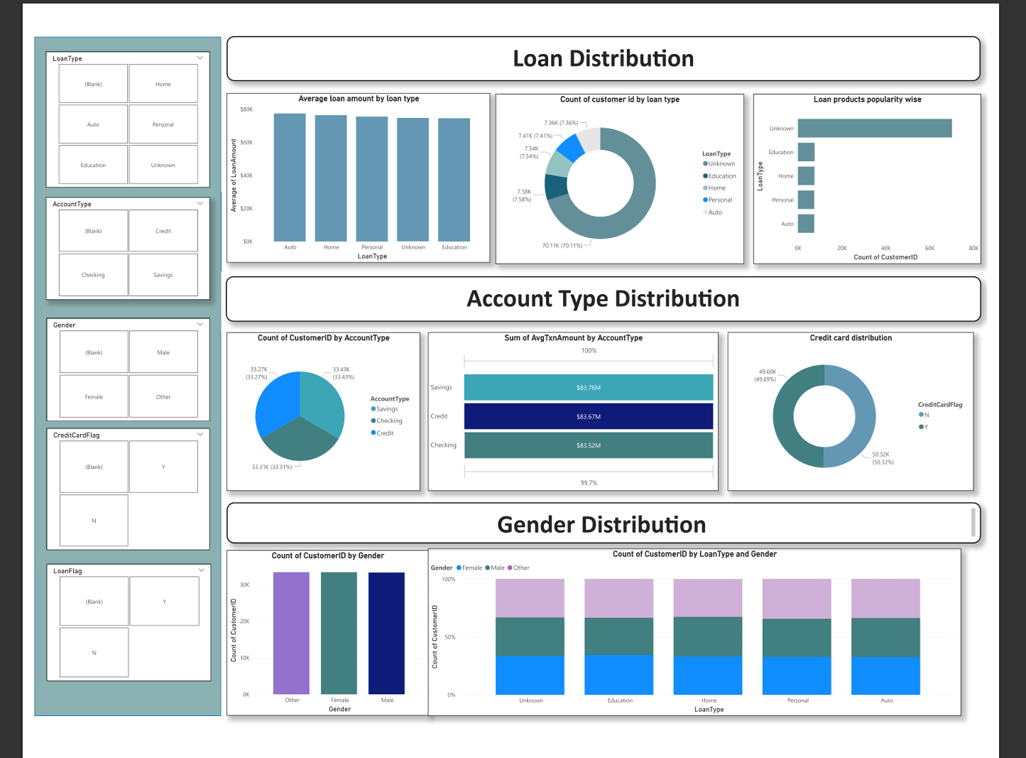

C)Tableau Public Edition Dashboard:
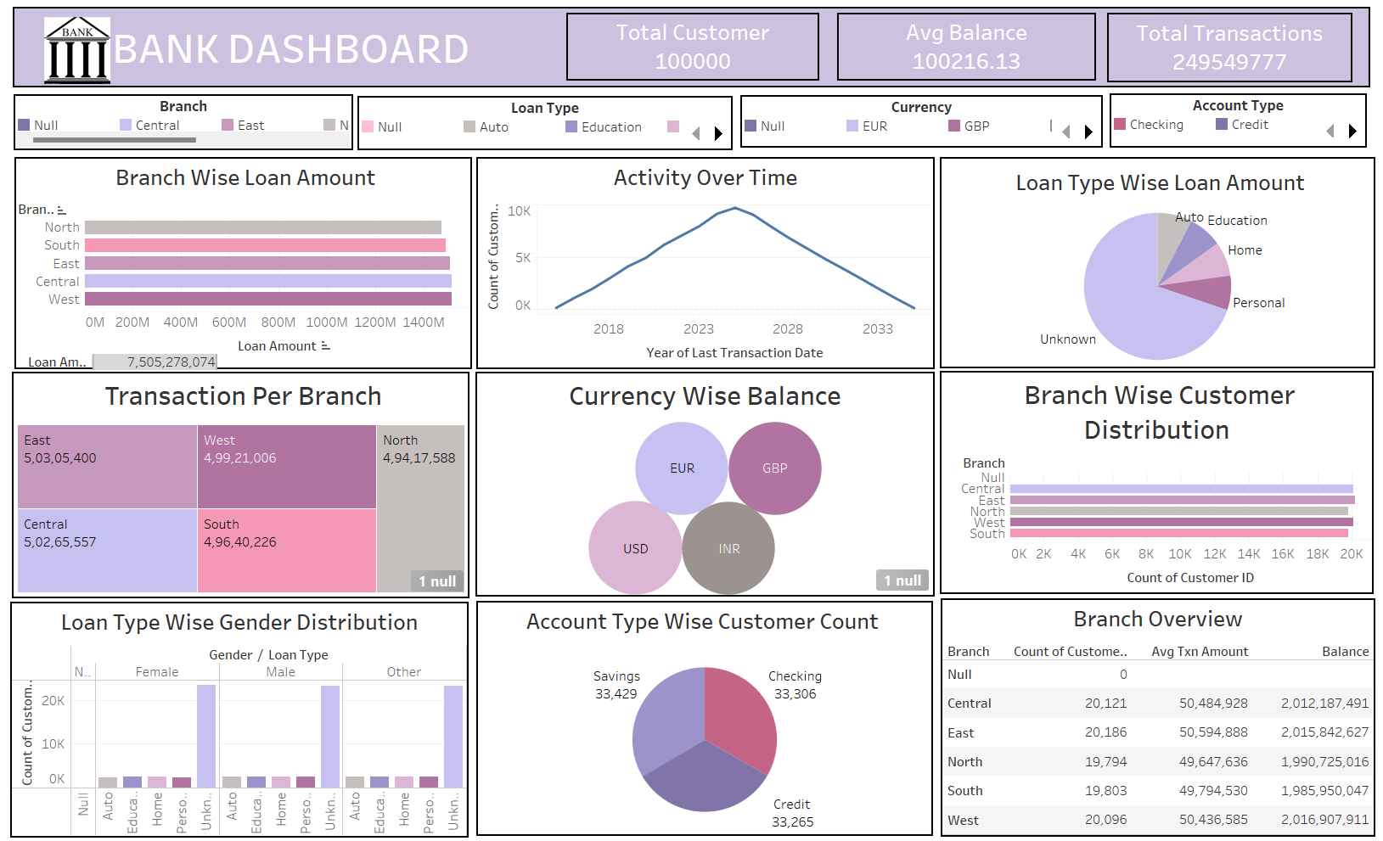

6)Challenges faced :
- In above dataset there is some amount of missing and null values these values are removed .
- The columns which not really important in the project are removed.
- Check the datatype of every column is correct or not if not it is corrected .
- Date and time formatting.
- Performance issue with large data.
7)Conclusion:
The Bank dashboard built in Excel, Power BI and Tableau offers a comprehensive overview of customer account activities, loan distribution, and credit utilization within the bank. By transforming raw transactional data into meaningful visual insights, the dashboard effectively highlights tracking financial performance, identifying trends, assessing risk, and supporting data-driven decisions for customer engagement and business growth.

8)Future Scope:
- Advanced Data Integration
- Connect the dashboard directly to a live banking database or API for real-time updates.
- Merge with other datasets (customer demographics, branch locations, loan details) for deeper insights.
- Enhanced Data Visualizations
- Add interactive drill-down features for branch-wise, region-wise, and customer segment analysis.
- Include trend analysis charts to forecast deposits, withdrawals, and customer growth.
- Predictive Analytics
- Implement machine learning models to predict customer churn, loan default probability, or high-value customer acquisition.
- Use historical data to forecast transaction volumes and seasonal trends.
- Automated Alerts & Notifications
- Set up automated KPI alerts (e.g., sudden drop in deposits or surge in withdrawals).
- Email or message updates for key stakeholders.

